DAT702 Synthesis- Extended Proposal

Jason Tinsley Autumn 2021

Contents

Idea in brief 3

Introduction 5

Methodology 6

Summary of Contextual Repository 7

Documentation and analysis of test pieces 8

Plan of Work 9

Summary 11

References 12

**Idea in brief**

(Knochel, 2018)

**Introduction**

Describe the project and what it’s about. State the problem and / or area of interest and

research question(s). This is different from the abstract as: a) you go deeper, b) this is where

you outline the problem in depth, discuss key terms, structure of document. It segues into

the methodology, so you may find it easier to incorporate methods section into

introduction, and then put the document structure after methods...

**Methodology**

In a series of meetings, Penlee Museum requested an informal proposal that showed potential solutions to their accessibility issues. As a result of research and experimentation, the curators have been offered four potential solutions: A pseudo hologram-based image of the artefacts, a Virtual Reality simulation, 3D printed objects, and an Unreal Engine based interactive environment that can be used with a conventional game controller.  
 As proof of concept, two prototypes were built: the first is a small tablet-based holographic projection, and the second was a painted 3D print of an Anglo Saxon belt buckle. Both were presented to the curators and the MRes course leaders for appraisal.

In the following meeting, the curators expressed preference for 3D printed objects and the Unreal Engine based environment, due to the amount of space and financial investment that the hologram and VR based solutions will entail.

Physical artifacts will be scanned on-site using handheld LIDAR unit, then converted into a format compatible for both integration into Unreal Engine 5, and as an STL file appropriate for 3D printing.

Ideally, 3D prints will be created in resin and infilled with a suitable material in order to increase the perceived weight of the object. Due to the nature of resins, they do not offer the same tactile feel as the original object, but they are more than rugged enough to be handled regularly. For larger objects, Fused Deposition Modelling (FDM) printers will be used to reduce the need for assembly. However, due to the FDM process, the objects will require more finishing than their resin counterparts.

Ideally, a questionnaire presented to visitors to the museum featuring questions on the experience that they have had in handling physical 3D prints of objects and using an interactive digital environment should provide substantial amounts of data for analysis. In addition, with willing subjects, face to face interviews will also assist in the depth of information gathered. Although these views will be highly subjective, emerging trends should be able to be identified dependent on the quality and numbers of responses.

**Summary of Contextual Repository**

This is not the repo itself, just an overview – exploring theory and practitioners in your

chosen area, and how they inform your research. Please include a link (URL) to the repo.

While this is about summarising the content of the repo--for example, indicating where

there is consensus and or disagreement--it’s not simply a matter of listing all the key points

that arise in different theories etc. Your job is to pull out of this material the key issues that pertain to your project.

**Documentation and analysis of test pieces**

This might include material produced for, or generated within the workshop. You can use

diagrams, sketches, photographs, storyboards, maps, text etc.

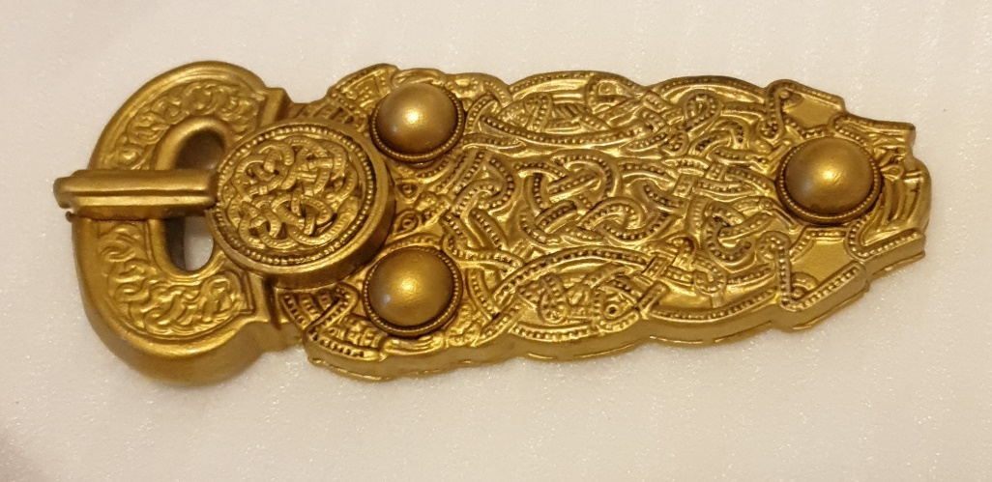

Figure : 3d Print of the Sutton Hoo Great Buckle (Tinsley, 2021)

**Plan of Work**

list work to be completed, broken down into key milestones with estimates of when these

should take place. For example, thinking about what separate chapter topics might be, or

different aspects of the production process of your final project. This element may take the

form of time-ordered list, Gantt chart or similar.

A very generic list-type example of this might be something like this:

Chapter 1: Introduction

Chapter 2: Literature review

Chapter 3: Methodology

Chapter 4: Results

Chapter 5: Discussion

Chapter 6: Conclusion

Though a few things should be said about this:

Firstly, there is no “right” structure... there are lots of different ways to structure a research

project. The above is typically in a science or technology context, but might not fit perfectly in for an art or design project.

Secondly, this outline might be clarified much further by specifically referencing your topic.

For example, instead of “Chapter 2: Literature Review” you might say "Overview of Anxiety treatments and Virtual Reality”... this isn’t just clearer, it might also help you keep on topic.

Thirdly, the above list doesn’t include anything about the practical milestones involved in

the project. Are you going to be doing field work? Are you going to be interviewing people? Will you need to test prototypes (how long will this take)?

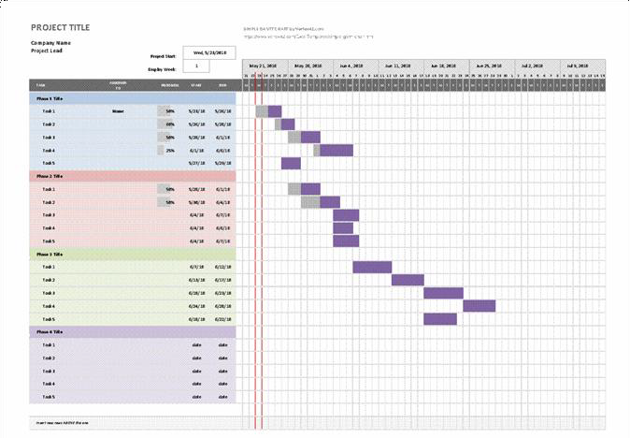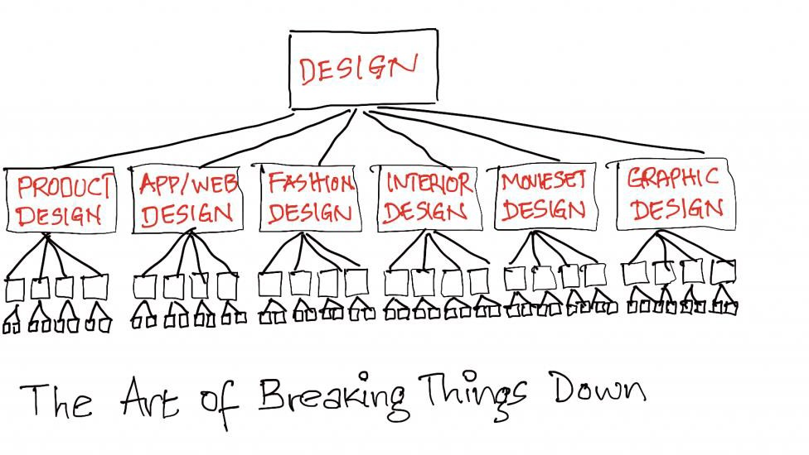

**Fig 3. An example of a Gantt Chart**

Fig. 4 An example of a flow-chart

**Summary**

An overview of the project, especially outline how this might be developed in future.

# Bibliography

Historic England, 2018. *3D Laser Scanning for Heritage: Advice and Guidance on the Use,* Swindon: Historic England.

Karsenti, T. P. S., 2020. Teaching history with the video game Assassin’s Creed: effective teaching practices and reported learning. *Review of science, mathematics & ICT Education,* 14(1), pp. 27-45.

Knochel, A. D. W.-H. H. P. A., 2018. Touching to See: Tactile Learning, Assistive Technologies, and 3-D Printing. *Art Education,* 71(3), pp. 7-13.

Tinsley, J., 2021. *3D print of the Sutton Hoo Great Buckle.* Launceston: Jason Tinsley.

Ubisoft, 2009. *Assassin's Creed 2,* Montreal: Ubisoft Montreal.

Ubisoft, 2010. *Assassin's Creed Brotherhood,* Montreal: Ubisoft Montreal.

Ubisoft, 2011. *Assassin's Creed: Revelations,* Montreal: Ubisoft Montreal.

Yee, N., 2016. *What we learned from 250,000 Gamers.* New York, Proceedings of the 2016 Annual Symposium on Computer-Human Interaction in Play (CHI PLAY 16).

Zagal, J. D. M., 2020. *A Typology of Imperative Game Goals.* [En ligne]   
Available at: http://gamestudies.org/2003/articles/debus_zagal_cardonarivera  
[Accès le 24 November 2021].

**Appendix A**

Appendices are anything not part of the main submission. For example, you could include

interview transcripts, put them in the appendix, and it wouldn’t affect your wordcount.

Or you might include an overview of your approach to the ethics of your research project.

Or evidence of sign-off from research participants.